##### Chapter 3 PacketTracer Introduction

**Learning objectives**

Examine the PacketTracer software package.

Implement a simulated network environment.

Configure the devices on the simulated network.

**Procedure**

In the following lab you have to following a series of steps to implement a network with one subnet.

**Step 1:**

Open PacketTracer and on the bottom left of PacketTracer choose ‘End devices’. Drag and drop a PC, a laptop, a server and a printing devices onto the PacketTracer program as in figure 1.

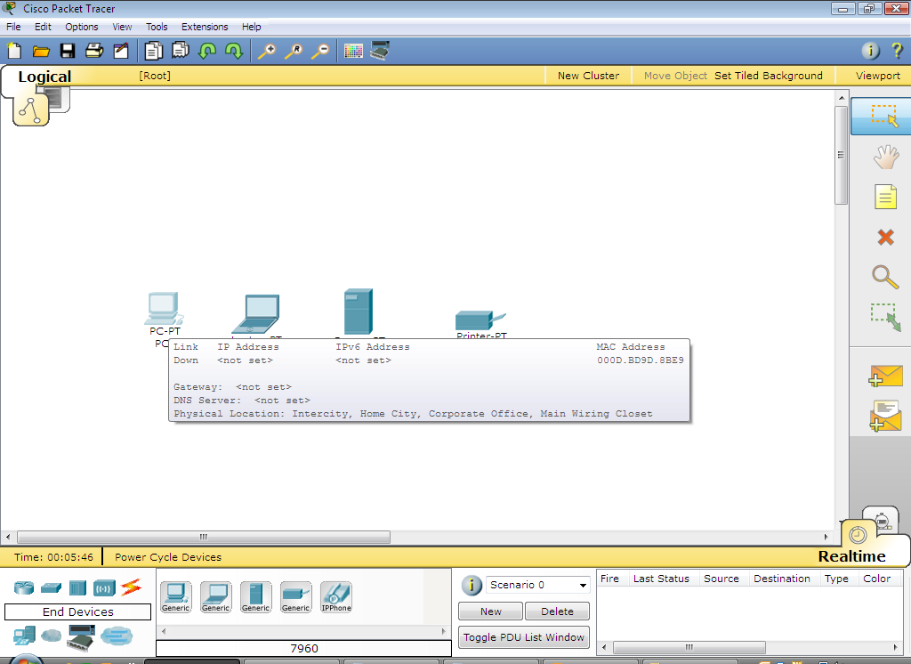

Figure 1: Drag and drop these end devices

**Step 2: Configure the IP address of the components on the network**

Use the IP addresses shown in Table 1 below and configure the devices. In Table 1 the IP address configurations of each device is given. In the screen shots in Figures 2 to 6 is an example of how to change the IP settings on a workstation. To change the configurations of the other devices is very similar. Double click on the device to change its configuration.

LAN 1

|  |  |  |  |
| --- | --- | --- | --- |
| Device | IP | Subnet Mask | Default Gateway |
| Workstation | 192.168.1.2 | 255.255.255.0 | 192.168.1.1 |
| Server | 192.168.1.3 | 255.255.255.0 | 192.168.1.1 |
| Laptop | 192.168.1.4 | 255.255.255.0 | 192.168.1.1 |
| Printer | 192.168.1.5 | 255.255.255.0 | 192.168.1.1 |

Table 1

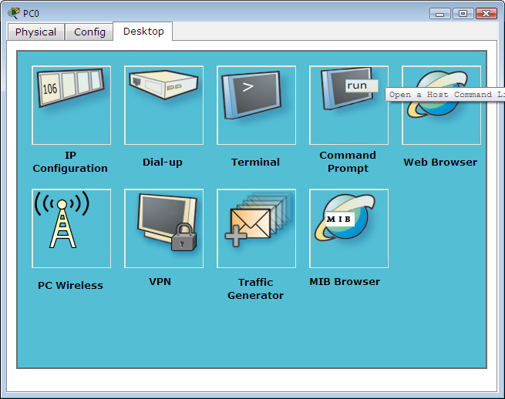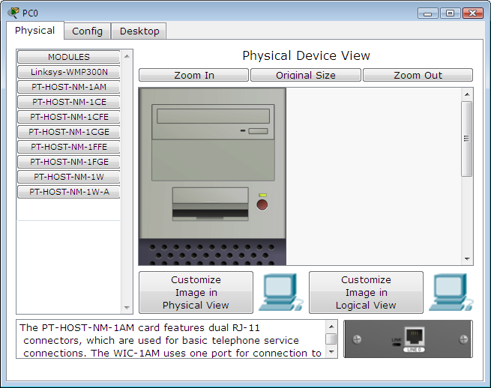

Figure 2: Double click on end device Figure 3: Choose desktop tab

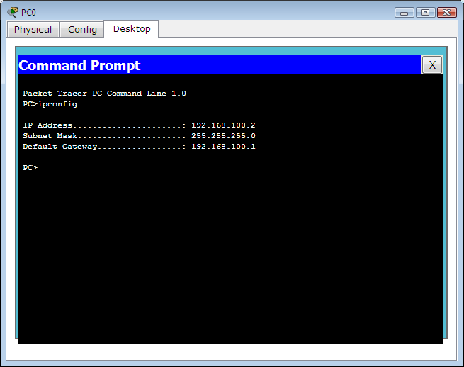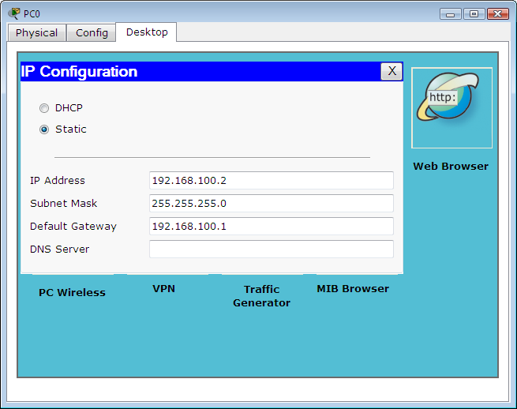

Figure 4:Set IP configuration Figure 5: Check configuration using ipconfig

Step 2 questions:

**Step 3: Add switch**

Drag and drop a switch onto the PacketTracer program. Connect the devices to the switch by using an appropriate cable. The network should look like figure 6.

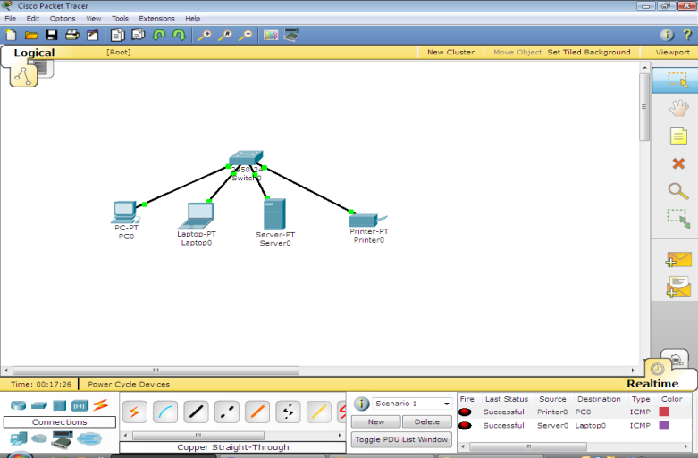

Figure 6: Connecting end devices to the switch

**Step 4:**

Add a second LAN with the devices and configuration listed below in Table 2. Connect the devices in LAN 2 together using a switch.

**LAN 2**

|  |  |  |  |
| --- | --- | --- | --- |
| Device | IP | Subnet Mask | Default Gateway |
| Workstation | 192.168.1.11 | 255.255.255.0 | 192.168.1.1 |
| Server | 192.168.1.12 | 255.255.255.0 | 192.168.1.1 |
| Laptop | 192.168.1.13 | 255.255.255.0 | 192.168.1.1 |
| Printer | 192.168.1.14 | 255.255.255.0 | 192.168.1.1 |

Table 2

**Step 5:**

Connect LAN 1 and LAN 2 together using an appropriate cable. The network should look like figure 7.

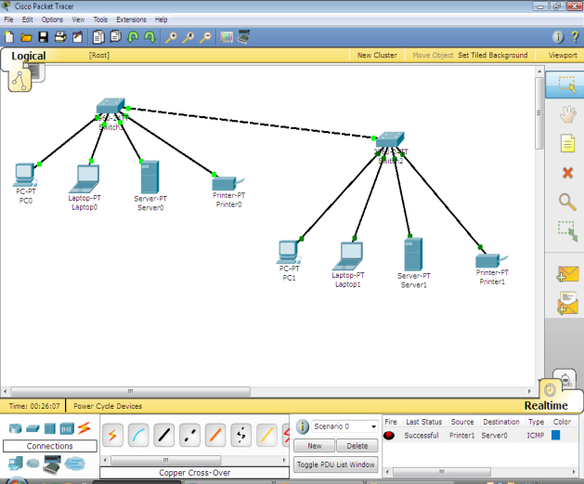

Figure 7:

**Step 5 questions**

**Question:** Can you ping between every device on the network?

ANS:

**Question:** Can you ping the switch?

ANS:

**Question:** What is the switches IP address?

ANS:

**Step 6: Add a router to the network.**

Connect the router to the switch using an appropriate cable as show in figure 8 below.

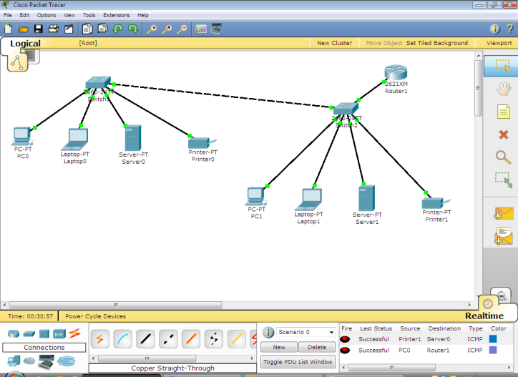

Figure 8: Addition of a router to the network

You will need to configure the router (double click on the router and choose CLI).

**Command 1: enable**

**Command 2: Router #config t**

**Command 3: Router (config)# interface fastethernet0/0**

**; note it can also be fastethernet0/0, fastethernet0/1 or serial0/0, serial0/1**

**Command 4: Router (config-if)# ip address 192.168.1.1 255.255.255.0**

**Command 5: Router (config-if)# no shutdown**

**End of Lab activity**